C programming report

700051535

I assumed that the cars are teleporting in the front of the line if the queue is clear, if not, they teleport to the last place.

Things I tried first:

I started writing pseudocode, deciding which to use: Arrays, or an integer for the queues. Because I thought we don’t really need any properties about any car, hence we can just keep them as an integer. Below is the pseudocode I tried before implementing the idea now I am working on.

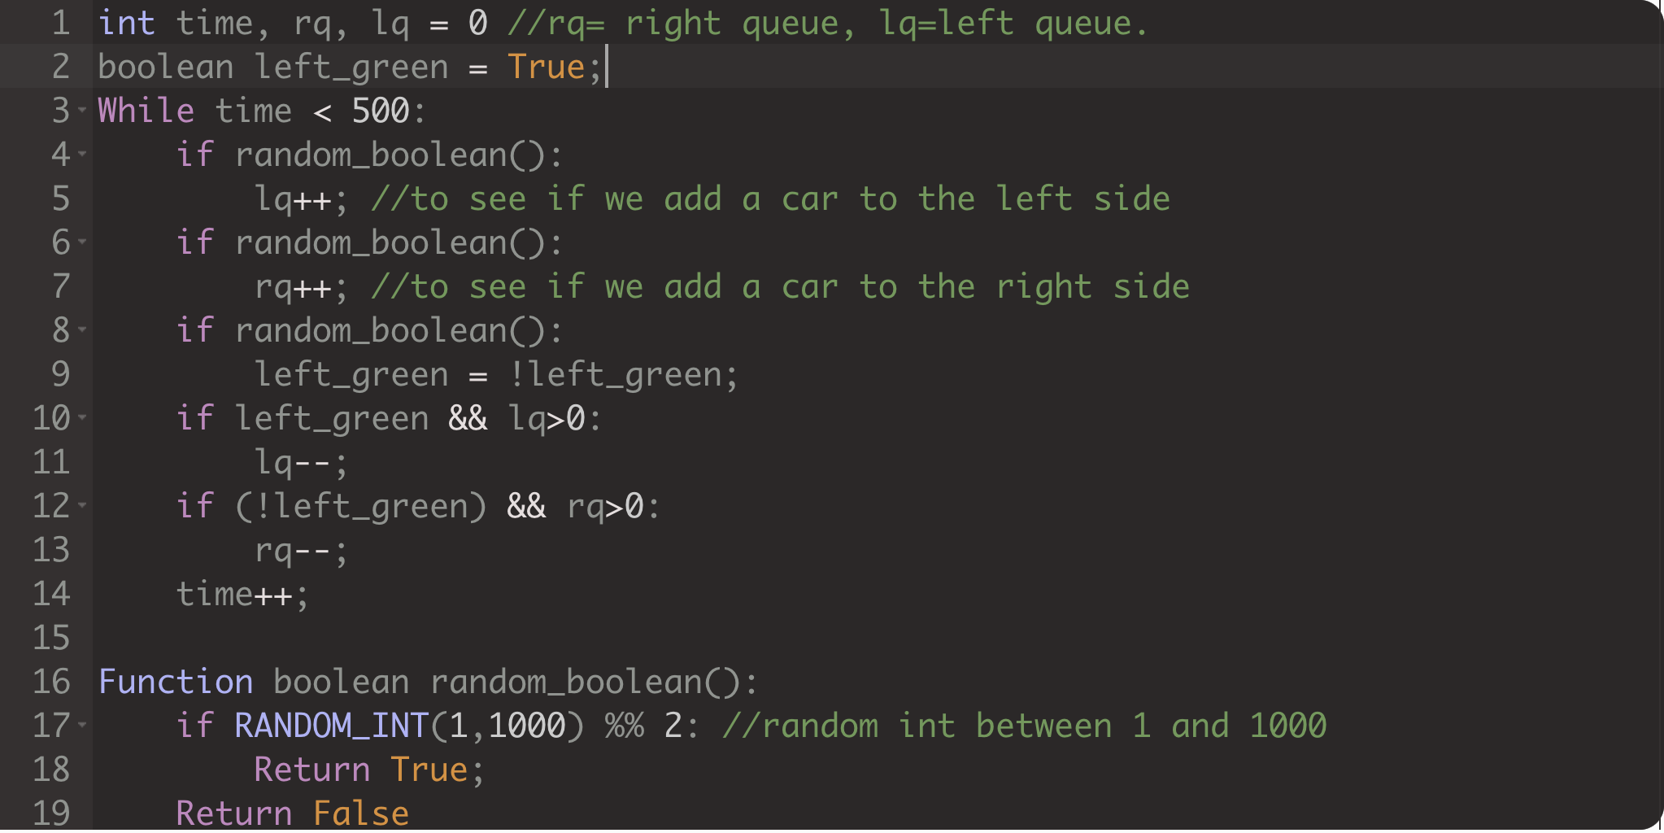

If I decided to work on that plan, my project would look like the C version of the code above, which is quite useful if I wasn’t going to keep any timestamp for the cars.

I also thought of keeping the queue as an array, but that also would not be useful. Because that way I would need to delete the cars which are passing the lights, but I needed to keep the values to create a printout at the end of the program.

* I decided to do the program as modular as I can do. Therefore, I created plenty of functions to run this entire code.
* I was going to do a simulation multi-runner for better results, but I couldn’t, due to my poor time management skills. The clearance time doesn’t work because of the same issue. I couldn’t force my mind even focus on it.
* Therefore, I did it all in one program.

Here is an output from my first simulation:

Here, light change time is one timestep.

This is the final output, I had to do it with only one run, because I couldn’t handle strings and arguments good enough. Clearance time here is a big lie,

The clearance time for each queue decreases if their max light time is greater than the other one.

If arrival rates and light periods for both sides are the same, it creates a result like this.

If we decide to torture one side by giving the rate 100 and light period 1, the waiting time increases to huge amounts.